**Physics 20 - Lesson 20**

**Vertical Uniform Circular Motion**

/44

1. Each free body diagram is worth 2 marks for a total of 12 marks.

A. Swinging on a rope, at lowest position. No friction.

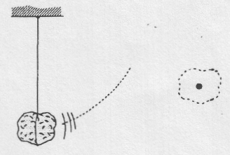

B. Tied to a post and moving in a circle at constant speed on a frictionless horizontal surface. Coming straight out of the paper.

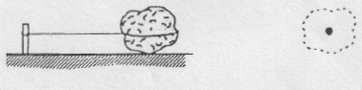

FN

Fg

FT

FT

Fg

D. Swinging on a rope. No friction.

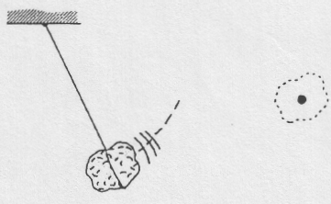

C. Tied to point A by a string. Moving in a horizontal circle at constant speed. Not resting on a solid surface. No friction. Coming straight out of the paper.

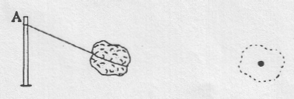

FT

Fg

FT

Fg

E. Swinging on a rope, at the top of a vertical circle.

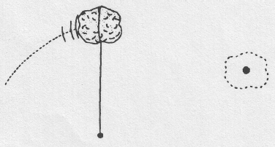

F. Riding on a horizontal disk that is rotating at constant speed about its vertical axis. Friction prevents rock from sliding. Rock is moving straight out of the paper.

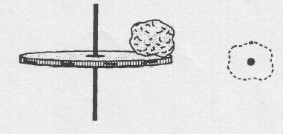

FN

Fg

Ff

FT

Fg

2)



Top



/5



Top

3)

/4



4)

•

Bottom



/8

The maximum tension occurs at the bottom of the circle

5)



•

Bottom



/6

6)



Top



/9



•

Bottom

